ANNUAL FISHWAY
STATUS
REPORT

For

BONNEVILLE DAM

1999

By

Jennifer D. Sturgill
Erich G. Gaedeke
Tammy M. Mackey

U. S. Army Corps of Engineers
CENWP-OP-B
Bonneville Lock & Dam
Cascade Locks, OR 97014
(541) 374-8375

21 December 1999
TABLE OF CONTENTS

INTRODUCTION 2
FISHWAY OPERATION AND ACTIVITIES 3
Auxiliary Water System (AWS) Closures 4
Fish Unit Outages 4
Fish Facility Outages and Maintenance 4
Fish Removal 6
VBS/STS Inspections 8
Table 1. Submersible Traveling Screen (STS) Inspections 8
Zebra Mussels 9
GLOSSARY 10

INTRODUCTION

This document summarizes fish impacting activities that occurred at Bonneville Lock & Dam from 1 November 1998 through 30 November 1999. This report primarily summarizes weekly reports that were produced throughout the year.

This report is required by the Corps of Engineers’ North Pacific Division, as described in the Fish Passage Plan (FPP) . The FPP contains the following surveillance and reporting requirements. “Project biologists shall inspect fish passage facilities at the frequencies listed in the juvenile and adult fish facilities operating criteria sections. The (weekly) reports shall include: any out of criteria situations observed and subsequent corrective actions taken; equipment malfunctions, breakdowns or damage, along with a summary of resulting repair activities; adult fish control calibrations; STS and VBS inspection; any unusual activities which occurred at the project which may affect fish passage.”

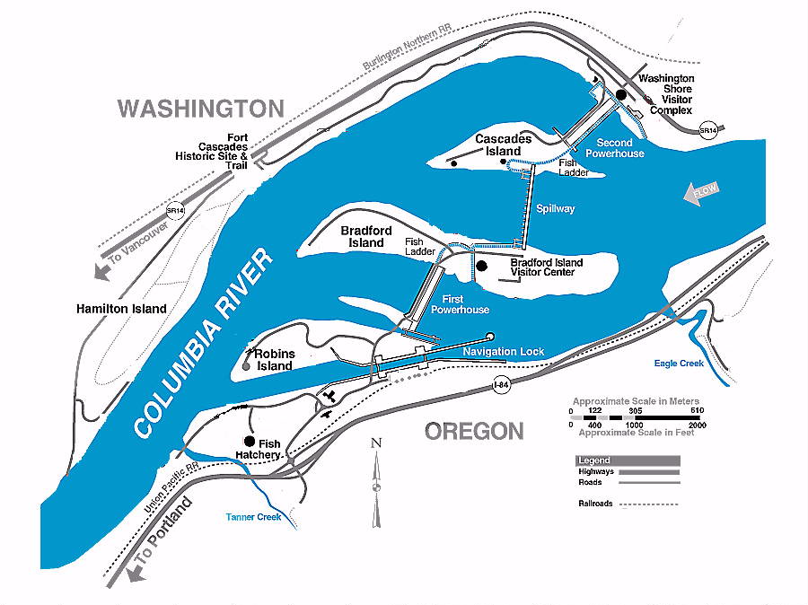

Figure 1 Bonneville Lock & Dam.
The project and fish passage facilities are described in the Fish Passage Plan¹. Details of operation are described particularly well in two COE drawings, one describing facilities at PH1 and Cascades Island and one describing facilities at PH2. In summary, the project comprises two powerhouses, a spillway and two navigation locks. The older of the two navigation locks has not operated since early 1993. There are four adult fish ladders for upstream migration, one at PH1, one at the south end of the spillway, one at the north end of the spillway and one at PH2. There are two Juvenile Bypass Systems for downstream migration, one at each powerhouse.
Acronyms and jargon are used freely in this report. The reader can find definitions in the glossary.

FISHWAY OPERATION AND ACTIVITIES
Fish Passage Plan (FPP) Violations

The following are the results of project operations daily fishway inspections for 1999. Project biologists are required to conduct at least three inspections per reporting week. Control room operators inspect fishways daily. The following table shows the FPP violation, the number of times the item was found out of criteria and the percentage (rounded to the nearest tenth) of times the item was found to be IN criteria. The following data is based on a total of 136 inspections from 1 November ’98 to 30 November ’99.

Auxiliary Water System (AWS) Closures

The AWS’ were closed for trashrack cleaning on several occasions during the 1998-1999 reporting year. Many closures were short in duration, for FV-3-9 and FV1-1, averaging less than 30 minutes. Others were much longer, lasting an average of 1 hour and 30 minutes. AWS trashracks were usually cleaned once each week with more frequent cleanings during the winter and the spring freshet. Dewatering of fishways was not included in the average closure times.

Fish Unit Outages

Fish Unit 1 (F1) was out of service from 5 December 1998 until 21 January 1999. It was taken out of service for annual maintenance and to facilitate PH2 ladder dewatering.
Fish Unit 2 (F2) was out of service from 12 December 1998 until 20 January 1999 for annual maintenance and to facilitate PH2 ladder dewatering.
Fish units 1 and 2 were out of service at other times during the year to “float” trash away from the trash racks. When drawdown measured one foot or greater, fish units were shut down. An adjacent unit was then operated to pull trash away from the fish unit trashracks. This process helped prevent debris and silt from accumulating in front of the fish units. Most of the unit outages associated with the floating of trash and debris occurred between midnight and 0300 to minimize impact on adult fish passage.
Between 1 November 1998 and 30 November 1999 there were a total of 7815 hrs for unit F1, and 7406 hrs for unit F2 during which no downtime was reported.

Fish Facility Outages and Maintenance

15 Oct 98 – 16 Mar 99 PH2 JBS improvements
24 Nov 98 - 25 Jan 99 AFC&MF annual maintenance
01 Dec 98 – 19 Jan 99 Cascades Island annual maintenance
07 Dec 98 - 19 Jan 99 Washington Shore ladder annual maintenance
15 Dec 98 – 15 Dec 98 PH1 DSM turned south for trash sweep repairs
13 Jan 99 – 09 Feb 99 PH1 JBS annual maintenance.
20 Jan 99 – 09 Feb 99 Bradford Island Ladder annual maintenance
22 Jan 99 – 09 Feb 99 PH1 PCC (unit 9 and northward) annual maintenance
10 Feb 99 – 26 Feb 99 PH1 PCC (south end) repair grating on FG2-1
23 Feb 99 – 26 Feb 99 AFC&MF partial dewater PIT tag detector installation
03 May 99 – 03 May 99 PH1DSM turned south for trash sweep repairs
09 Aug 99 – 10 Aug 99 PH1 DSM dewatered for trash sweep repairs
11 Aug 99 – 16 Aug 99 AFC&MF dewatered to assist NMFS PIT tag detector testing
02 Nov 99 → AFC&MF annual maintenance
04 Nov 99 – 10 Nov 99 PH1 DSM turned south for trash sweep repairs
22 Nov 99 – 23 Nov 99 PH2 DSM diverted to ERC for switchgate repairs

Turbine Outages and Dewaterings (outages of at least 24 hours)

Date Unit Reason for Outage

01 Nov 98 - 31 Oct 99 4 Major rehab contract
01 Nov 98 - 24 July 99 6 Stator failure/ Rehab
01 Nov 98 - 10 Nov 98 7 Repair draft tube door
01 Nov 98 – 30 Nov 98 15 Differential trip
16 Nov 98 - 30 Nov 98 9 5 yr. overhaul
17 Nov 98 - 19 Nov 98 5 Test stator iron
19 Nov 98 - 30 Nov 98 F2 Stator readings
23 Nov 98 - 24 Nov 98 18 DSM2 orifice modification
28 Nov 98 – 30 Nov 98 12 Gov. relay valve leak
01 Dec 98 – 15 Dec 98 15 Differential trip
01 Dec 98 – 20 Jan 99 F2 Annual maintenance/fishway outage
05 Dec 98 – 21 Jan 99 F1 Annual maintenance/fishway outage
16 Dec 98 – 18 Dec 98 10 Back iron inspection
04 Jan 99 – 19 Jan 99 14 DSM2 orifice modification
19 Jan 99 – 27 Jan 99 13 DSM2 orifice modification
21 Jan 99 – 22 Jan 99 10 PSC dive
27 Jan 99 – 31 Jan 99 12 DSM2 orifice modification
01 Feb 99 – 03 Feb 99 12 DSM2 orifice modification
02 Feb 99 – 19 Feb 99 16 Breaker pole failure
02 Feb 99 – 05 Feb 99 F2 DSM2 orifice lights modification
03 Feb 99 – 11 Feb 99 11 DSM2 orifice modification
22 Feb 99 – 23 Feb 99 17 DSM2 orifice modification
04 Mar 99 – 12 Mar 99 8 ESBS install
09 Mar 99 – 31 Mar 99 SS Bad processor
18 Mar 99 – 19 Mar 99 5 Transducer install
26 Mar 99 – 28 Mar 99 15 STS failure
29 Mar 99 – 30 Mar 99 2 Transducer install
01 Apr 99 – 22 Apr 99 SS Bad processor
03 Apr 99 – 05 Apr 99 8 ESBS failure
12 Apr 99 – 13 Apr 99 11 Repair distrib. valve
20 Apr 99 – 29 Apr 99 5 Brakes smoked
16 May 99 – 17 May 99 9 Annual maintenance
12 Jul 99 – 31 Jul 99 14 4-year overhaul
28 Jul 99 – 29 Jul 99 6 Dive to remove PSC
01 Aug 99 – 12 Aug 99 14 4-year overhaul
02 Aug 99 – 30 Nov 99 16 Rewedge generator
09 Aug 99 – 10 Aug 99 15 T-12 annual maintenance
09 Aug 99 – 10 Aug 99 17 T-12 annual maintenance
09 Aug 99 – 10 Aug 99 18 T-12 annual maintenance
11 Aug 99 – 12 Aug 99 11 T-11 annual maintenance
11 Aug 99 – 12 Aug 99 12 T-11 annual maintenance
11 Aug 99 – 12 Aug 99 13 T-11 annual maintenance
19 Aug 99 – 24 Aug 99 6 Inspection by contractor
19 Aug 99 – 25 Aug 99 14 Turbine bearing low oil
24 Aug 99 – 25 Aug 99 7 Bank 7/8 annual maintenance
24 Aug 99 – 25 Aug 99 8 Bank 7/8 annual maintenance
25 Aug 99 – 30 Nov 99 10 38 Relay on upper guide bearing
09 Sep 99 – 09 Nov 99 5 Install fish release pipes
04 Oct 99 – 06 Oct 99 3 Bank 3/4, unit semi-annual maintenance
04 Oct 99 – 06 Oct 99 11 Possible hub oil leak
04 Oct 99 – 08 Oct 99 6 STS pulled for index testing
06 Oct 99 – 07 Oct 99 1 115KV sect. disconnect work
12 Oct 99 – 09 Nov 99 6 Install fish release pipes
03 Nov 99 – 06 Nov 99 9 Transformer bank differential
08 Nov 99 – 30 Nov 99 11 4-year overhaul

Fish Removal

Fish passage facilities and turbine units are taken out of service and dewatered to allow for inspection, preventative maintenance, repairs, and modifications. As facilities and turbine units are dewatered, project biologists, outside agency personnel, and other project personnel follow procedures outlined in the Fish Passage Plan and detailed in the Fish Salvage Plan to minimize impacts on fish. Adult fish recovered are typically released into the forebay above the new navlock. Sturgeon and juvenile fish are released below the dam at Hamilton Island. The following is a summary of the number of fish that were removed during facility and turbine unit dewaterings. All fish were recovered in good condition unless otherwise noted.

Unit 7 Tail logs pulled (11/09/98): Recovered 4 chubs, and 1 small sturgeon.

Unit 9 (11/16/98): No fish in the draft tube. Dipped the gatewells and recovered approximately 2000 juvenile shad.

Adult Fish Facility (11/24/98): Recovered 1 adult shad, approximately 100 chubs, 5 lamprey, crayfish, and 1 adult Chinook.

Unit 9 Tail logs pulled (11/30/98): Recovered 6 sculpin, several dead juvenile shad.

Cascade Island (12/01-02/98): Recovered approximately 200 juvenile shad from FV5-3/5-4, 12 chubs, 4 adult steelhead, 3 adult chum, and 5 lamprey. Several additional chubs were recovered from beneath diffuser gratings.

Washington Shore Fish Ladder to Tailwater (12/09/98): Recovered 6 adult steelhead, 4 lamprey, 2 juvenile shad, 2 juvenile salmonids, and approximately 50 chubs and northern pikeminnows.

Powerhouse 1 Juvenile Bypass System (1/13/99): Recovered 15 juvenile salmonids, 4 juvenile suckers and, 4 sculpin.

PH1 Collection Channel from Unit 9 north (1/22/99): Recovered 2 adult steelhead and 5 resident river fish.

Bradford Island/ A&B Branches/ diffuser chambers to tailwater (1/20-21/99): Recovered 87 steelhead (23 wild summer and winter, 52 hatchery summer and winter, 12 unknown rearing or race), approximately 75 resident river fish, and approximately 40 lamprey.

PH1 South Collection Channel to Unit 2 (2/10/99): Recovered 1 juvenile shad, 3 lamprey, and approximately 50 resident river fish.
Adult Fish Facility (2/21/99): Recovered 11 floy tagged steelhead, pushed approx. 75 floy tagged steelhead from bottom of return ladder to bottom of the ladder into AFF.

PH1 DSM (5/03/99): Recovered approximately 300 juvenile salmonids, 100-200 possible morts.

Unit 14 (7/12/99): Recovered 5 one to three foot sturgeon, 4 catfish, 1 lamprey, and approximately 30 juvenile salmonids. 1 juvenile salmonid infested with fungus.

PH1 DSM (7/28/99): Recovered 6 juvenile Chinook.

PH1 DSM (8/09/99): Recovered 1 juvenile Chinook.

Adult Fish Facility (8/11/99): Recovered 1 sturgeon, 3 resident fish, 3 juvenile salmonids, 6 lamprey, 16 adult steelhead (1 dead), and approximately 300 adult shad.

Unit 10 (8/26/99): Recovered 1 juvenile salmonid, 5 lamprey, and 30 sturgeon. 21 of the sturgeon were dead or dying because of fatal injuries caused by the PH1 floor drain.

Unit 5 (9/9/99): Recovered 2 lamprey, 14 sturgeon. 8 of the sturgeon were dead or dying because of fatal injuries caused by the PH1 floor drain.

Unit 11 Scroll case (10/05/99): Recovered 1 dead sturgeon.

Unit 5 Tail logs (10/08/99): Recovered 6 sturgeon, 2 sculpins, 1 peamouth, and 1 dead adult lamprey.

Unit 6 (10/12/99): Recovered 4 sturgeon. 1 sturgeon was dead. Cause of death unknown.

Adult Fish Facility (11/02/99): Recovered 4 fall Chinook jacks, 5 peamouth, 2 adult lamprey, 1 sculpin, approximately 10-20 adult shad.

Unit 6 Tail logs (11/03/99): Recovered 6 sturgeon, 5 peamouth, and several sculpins.

PH1 DSM (11/04/99): Recovered 2 hatchery steelhead, 1 wild steelhead, 1 juvenile salmonid, and about 10 juvenile shad. Emergency dewatering due to screen cleaner failure.

Unit 11 (11/08/99): Recovered 9 sturgeon, 2 adult lamprey.

DSM2 Outfall (11/22/99): Recovered 2 adult hatchery steelhead. Switched to ERG release so work could be done on switchgates.

PH1 DSM (11/29/99): Recovered 50 juvenile shad and 3 juvenile salmonids.
VBS/STS Inspections

The Fish Passage Plan requires STS and VBS inspections. STS inspections are to be conducted once per month, and VBS inspections are to be conducted once every two months. Since each STS has a timer that automatically accumulates (showing elapsed time of operation), STS inspection frequency can additionally be measured by run time. The equivalent of one month of continuous operating time is 720 hours. Table 1 and Table 2 below show the STS inspection dates and run times, and VBS inspection dates, respectively.

Table 1. Submersible Traveling Screen (STS) Inspections
[Run hours between inspections are shown in parentheses]

Table 2. Vertical Barrier Screen (VBS) Inspections

Zebra Mussels

We continued to watch for the arrival of zebra mussels. Fortunately, we have not seen any yet. The monitoring station is checked once weekly for colonization. It is understood that it should be considered just a matter of time before they arrive in this part of the country. Zebra mussels cause serious problems in parts of the country where they are already established. Therefore, we monitor for the earliest indication of their arrival so that funding programs can be developed quickly enough to deal with the problem when it becomes an issue here.

GLOSSARY
AFC&MF Adult Fish Collection and Monitoring Facility. The building attached to the second powerhouse main fish ladder where adult fish are trapped for monitoring or removal.
BiOp Biological Opinion.
BON Bonneville Lock & Dam.
Downwell This is the opening through which water and fish drop into after excess water is drawn away through the dewatering screen. It is the beginning of the conduit that delivers fish around the dam to the tailrace at PH1.
DSM Downstream Migrant transportation channel. The channel in the juvenile fish bypass system that transports fish from the gate-well orifices to the downwell.
CRITFC Columbia River Intertribal Fish Commission.
FFU Fisheries Field Unit. Unit in the Corps of Engineers’ Portland District Construction, Operations and Readiness Division that conducts fish related evaluations and monitoring.
FGE Fish Guidance Efficiency. Proportion of fish entering turbine intakes that are guided into the juvenile bypass system.
Forebay That area of a reservoir immediately upstream of a dam.
FPC Fish Passage Center.
FPE Fish Passage Efficiency. Proportion of juvenile fish that pass the dam by non-turbine routes.
FPP Fish Passage Plan.
JBS Juvenile Fish Bypass System.
JFMF Juvenile Fish Monitoring Facility (PH2)
Kcfs Thousand cubic feet per second.
NDE North Downstream Entrance. See NUE.
NUE North Upstream Entrance. Refers to one of the four large overflow weir adult fishway entrances at PH2.
NFH National Fish Hatchery
NMFS National Marine Fisheries Service.
NPP Corps of Engineers, North Pacific Division, Portland District.
ODFW Oregon Department of Fish & Wildlife
OOS Out Of Service.
PCC Powerhouse Collection Channel. The part of the powerhouse adult fishway that fish swim through to reach the base of the fish ladder.
PH1 Bonneville First Powerhouse.
PH2 Bonneville Second Powerhouse.
Project Bonneville Lock & Dam.
SDE South Downstream Entrance. See NDE.
SUE South Upstream Entrance. See NDE.
STS Submersible Traveling Screen.
Tailwater The portion of a river immediately downstream of a dam or powerhouse.
TIE Turbine Intake Extension.
Tule Early spawning fall chinook.
UMT Upstream Migrant Transportation channel. This is the channel that passes through the second powerhouse and connects the Cascades Island ladder to the PH2 ladder.
VBS Vertical Barrier Screen.
WDFW Washington Department of Fish & Wildlife.

REFERENCES ? _____. 1997. Fish Passage Plan for Corps of Engineers Projects. U. S. Army Corps of Engineers, North Pacific Division, Portland, Oregon.
_____. Drawing: BDF-9-6-OAO/1 Fishway Operation, revised 1985. U. S. Army Corps of Engineers, Portland District, Bonneville Dam project.
_____. Drawing: BDF-9-O/I Fishway Operation, 1986. U. S. Army Corps of Engineers, Portland District, Bonneville Dam project.

